CS516 – Advanced Programming
Project Proposal

Project Title: EasyBook: Online Bookstore System

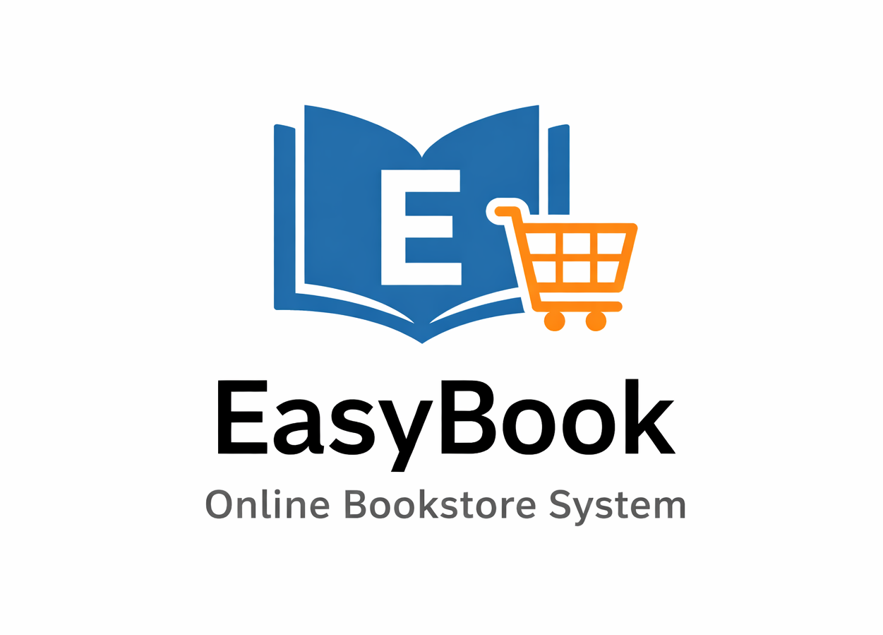

Members:
 | Name | ID | Role Participated in
1 | Mansour Ali Al-hutaylah | 2220005008 | Leader
2 | Saif Swailem AL-shammari | 2220001577 | Frontend
3 | Mutaeb Abdullah Alajmi | 2220005062 | Database
4 | Abdulelah Alzahrani | 2220004084 | Python Scripts
5 | Rayan Alalyani | 2220002890 | Testing & Documentation

Selected Programming Languages (Paradigms):

- Java – Object-Oriented Programming (OOP, MVC)
- Python – Procedural / Scripting

Brief Description:

The EasyBook is an inexpensive web-based bookstore which allows users to browse books, search by title, add items to their cart, and place orders. The core components of the application will all be developed in Java (including the user interface, business logic, and database access). Simple supporting functionality (such as generating sales reports, importing and exporting book data, and basic data processing) will use Python as a tool for accomplishing these tasks. The general design of the EasyBook system emphasizes (1) simplicity, (2) clarity, and (3) core functionality; no unnecessary complexity will be introduced into any part of the EasyBook system.

Main functions:

I. User Management
• Registering and logging in
• Managing user profiles
II. Book Management
• Showing available books
• Viewing book details such as title, author, price and category.
• Searching for books via title or author.
III. Shopping Cart
• Adding books to the cart.
• Removing books from the cart.
• Updating quantity.
• Calculating the total amount.
IV. Order Management
• Placing orders.
• Viewing the order summary.
• Storing order history.
V. Admin Functions (Basic)
• Adding a new book to the store.
• Updating information on a new book.
• Removing books from the store.
VI. Python Basic Features
• Generating basic sales reports (CSV/Excel).
• Importing and exporting book data.
• Analyzing the top selling books in general.

